Keypoint Detection in Plant Phenotyping: A Systematic Review of Methods, Challenges, and Emerging Trends
Jianye Chang^{1, 2, #}, Eleni Mangina³, and Sónia Negrão², Jue Ruan^{1, *}
1 Shenzhen Branch, Guangdong Laboratory for Lingnan Modern Agriculture, Genome Analysis Laboratory of the Ministry of Agriculture and Rural Affairs, Agricultural Genomics Institute at Shenzhen, Chinese Academy of Agricultural Sciences, Shenzhen, China.
2 School of Biology and Environmental Science, University College Dublin, Dublin, Ireland
3 School of Computer Science and UCD Energy Institute, University College Dublin, Dublin, Ireland

Abstract
Keypoint detection has emerged as a critical step in automated plant phenotyping, enabling precise measurement of morphological traits, organ localization, and structural modeling from high-throughput image data. Despite rapid advances in imaging technologies and computer vision algorithms, research on plant keypoint detection remains fragmented across species, modalities, and experimental conditions.
This study presents a systematic literature review (SLR) of keypoint detection techniques applied to plant phenotyping, covering works published between Jan 2010 and Jan 2027. Following PRISMA guidelines, we identified and analyzed 146 peer-reviewed studies retrieved from major scientific databases, including Web of Science, Scopus, and IEEE Xplore.
The reviewed studies are categorized into three major groups: (1) traditional image processing and feature-based approaches, (2) deep learning architectures such as CNNs, stacked hourglass, and transformer-based models, and (3) multimodal and 3D keypoint detection frameworks. We further summarize the applications of these methods in leaf tip localization, stem node detection, panicle structure analysis, and organ-level trait extraction. Quantitative performance comparisons reveal that deep learning methods consistently outperform traditional approaches in accuracy and robustness, although challenges persist in data diversity, annotation cost, and generalization across environments.
Finally, we highlight key trends and research gaps, including the need for standardized benchmarks, integration of multimodal sensing, and adoption of self-supervised or foundation models for large-scale phenotyping. This review provides a comprehensive synthesis of current progress and future opportunities in keypoint detection for plant phenotyping, serving as a foundation for the development of next-generation phenotyping pipelines.

1. Introduction
- 植物表型分析（plant phenotyping）是精准农业、作物改良和植物科学研究的重要基础。
- 随着高通量成像技术的发展（RGB、深度、近红外、激光雷达等），图像分析成为关键瓶颈。
- 在计算机视觉中，关键点是图像中具有独特性和可重复性的特定兴趣点。这些点作为结构紧凑的地标，代表着一个物体或一个场景，使机器能够更详细地理解和分析视觉内容。“关键点检测（keypoint detection）”是实现植物器官识别、姿态估计、结构建模的重要步骤（如茎尖、叶节点、果实顶点定位）。关键点检测技术正在重塑机器“视觉理解”的方式，为多个行业的数字化转型提供强大动力。从工业精密制造到医疗健康，从农业生产到日常人机交互，其应用潜力无限。
- 现有综述多聚焦于整体的植物图像分析或特定任务（如分割、分类），而对关键点检测这一目标检测的高级子任务缺乏系统性总结。同时，目前的算法和传感器研究发展迅速（传统图像处理 → 卷积网络 (CNN) → 高分辨率网络 (HRNet) → Transformer (ViTPose, PoseFormer) → 大模型统一方法 (UniPose, RTMPose, GPT-4V + MMPose在快速演进；RGB →光谱→激光雷达→多模态也在快速进化），但缺乏统一的对比与性能评估。也缺少对公开数据集、基准（benchmarks）和未来趋势的归纳分析。
- 提出核心问题：RQ1. 植物关键点检测任务目前主要应用在哪些植物器官和场景（如叶片、花、果实、根茎、整体结构）？RQ2. 植物关键点检测的方法学发展路径是怎样的？（从传统方法 → CNN/GCN → Transformer/生成模型）RQ3. 常用的数据集和评价指标有哪些？它们的局限性是什么？RQ4. 当前方法在植物关键点检测中主要面临哪些挑战？RQ5. 未来研究和技术趋势和潜在应用方向是什么？（如 3D建模、自监督学习、跨物种泛化、农业机器人等）
- 因此，本综述旨在基于几个问题进行系统性地总结、分析并比较植物表型关键点检测领域的算法、应用场景与性能表现，识别当前研究空白，并提出未来研究方向。
应用领域 (Applications)
表型分析：器官计数、尺寸与形态测量、生长监测
精准农业：机器人采摘、自动化修剪、物种识别
植物科学研究：植物姿态估计、生物力学分析
关键点定义 (Keypoint Definition)
器官中心点：花心、果实中心
形态特征点：叶尖/叶基、花瓣尖端、果梗连接点
结构连接点：分枝点、叶柄连接点
检测方法 (Detection Methods)
传统计算机视觉：SIFT、SURF、ORB
基于深度学习：热图回归、直接坐标回归
常用架构：R-CNN 系列、YOLO 系列、Transformer-based
挑战 (Challenges) ::icon(fa fa-exclamation-triangle)
遮挡问题、光照与环境变化、形态多样性与变形、数据获取与标注成本
未来趋势 (Future Trends) ::icon(fa fa-rocket)
3D 关键点检测、多模态数据融合、轻量化模型与边缘计算、无/弱监督学习、Foundation Models 应用

2. Methodology

2.1 Review objectives and Research questions
The primary objective of this review is to conduct a meta-analysis of current research on AI applications in 3D point cloud-based in plant phenotyping. To achieve this, we formulated a focused set of RQs to guide a detailed assessment of relevant literature. These RQs provided the foundation for our systematic literature review (SLR) and facilitated the collection of pertinent publications.
RQ1: Compared with 2D RGB etc. images, what are the advantages of 3DPC in plant phenotyping? What metrics can be used?
RQ2: What AI algorithms are used to analyze 3DPC? What available datasets can be found?
RQ3: What are the current trends and limitations of AI and 3DPC in analyzing plant phenotypic traits? What strategies can be implemented to improve its effectiveness?

2.2. Literature search strategy and search string
When conducting an SLR, the selection process must follow a rigorous and unbiased search strategy aimed at bringing together the broadest possible range of original studies that provide a solid evidence base to directly answer the posed RQs. Therefore, building upon effective methodologies identified in previous studies, the search and analysis process was meticulously designed to comprehensively incorporate all published research results. To ensure both comprehensiveness and depth, our literature search and analysis followed a structured three-stage approach.

2.3. Database selection
Web of Science, Scopus, IEEE Xplore

2.4. Article selection and quality assessment
Even with a comprehensive keyword-based search across databases, external, external factors may still lead to the inclusion of irrelevant papers into our database. Therefore, we have established clear inclusion and exclusion criteria to prevent bias in our results.

2.4.1 Inclusion criteria
- This study should be a book chapter, conference proceeding, or journal article;
- The study must use plant-related 3DPC data and apply artificial intelligence methods (e.g., machine learning or deep learning algorithms) for analysis or processing;
- The study must be published between January 1, 2010, and December 31, 2024;
- The study must focus primarily on plants, including but not limited to agricultural crops, forest vegetation, urban greenery, or similar plant types;
- The study must be written in English and be fully open-access.

2.4.2 Exclusion criteria
- The study does not primarily focus on plants (e.g., it focuses on animals, soil, or non-biological objects);
- The study does not use 3DPC data or rely solely on traditional statistical methods without artificial intelligence techniques;
- The study was published before January 1, 2010;
- The study is not fully open-access (e.g., only an abstract is available or it requires payment) or is written in a language other than English;
- The study is a review paper, commentary, or editorial article.

Perform descriptive analysis

The identified papers were then objectively reviewed and data was extracted and examined for the following items: research methodology, algorithm used, descriptive attributes of the models, journal, findings, and challenges and limitations. The results of this extraction were then documented in tabular format and evaluated independently by the authors and by an independent researcher to verify their eligibility. The resulting papers underwent thematic content analysis to reach a classification structure as discussed in the next section. Table 1 shows the distribution of the 80 articles in their respective journals. These articles were then analyzed to produce a taxonomy of deep learning applications in construction. Several iterations were conducted to reach the best taxonomy after reading the abstracts and the full papers. This resulted in six topics, which are: 1) equipment tracking, 2) crack detection, 3) construction work management, 4) sewer assessment, 5) 3D point cloud enhancement, and 6) miscellaneous topics. The detailed analysis of these topics is discussed in the next section.

3. Overview of Paper collected
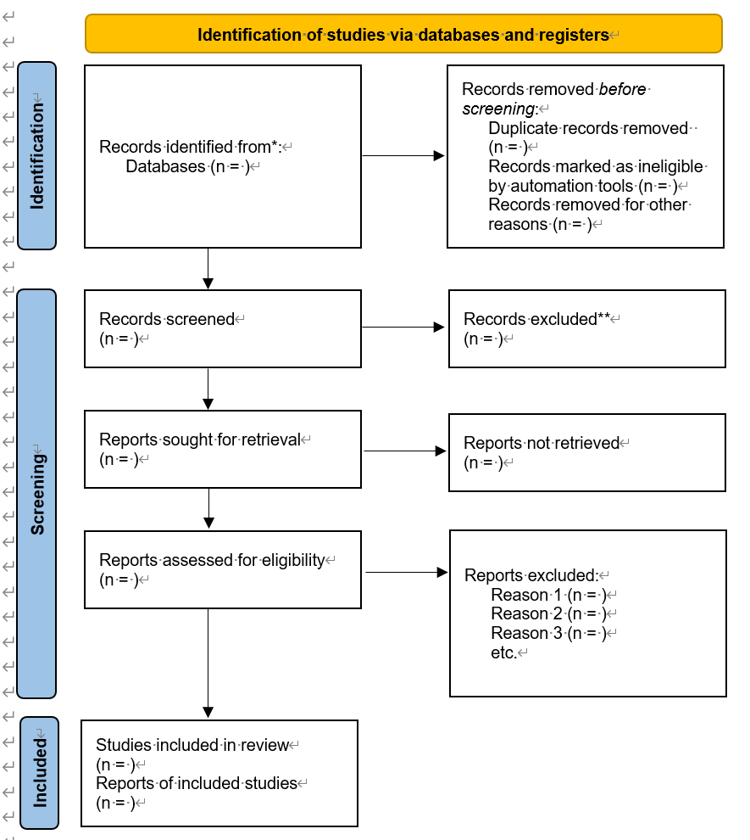
1.文献分布特征：最终筛选的273篇文献中，Web of Science贡献占比最高（23.8%，65篇），其次是ScienceDirect和PubMed（各21.9%，60篇），Scopus因覆盖范围较窄占比最低（2.2%，6篇）；研究作物以小麦（41篇）、玉米（39篇）、水稻（25篇）为主，其他作物研究较少，存在明显的“小麦中心”倾向。
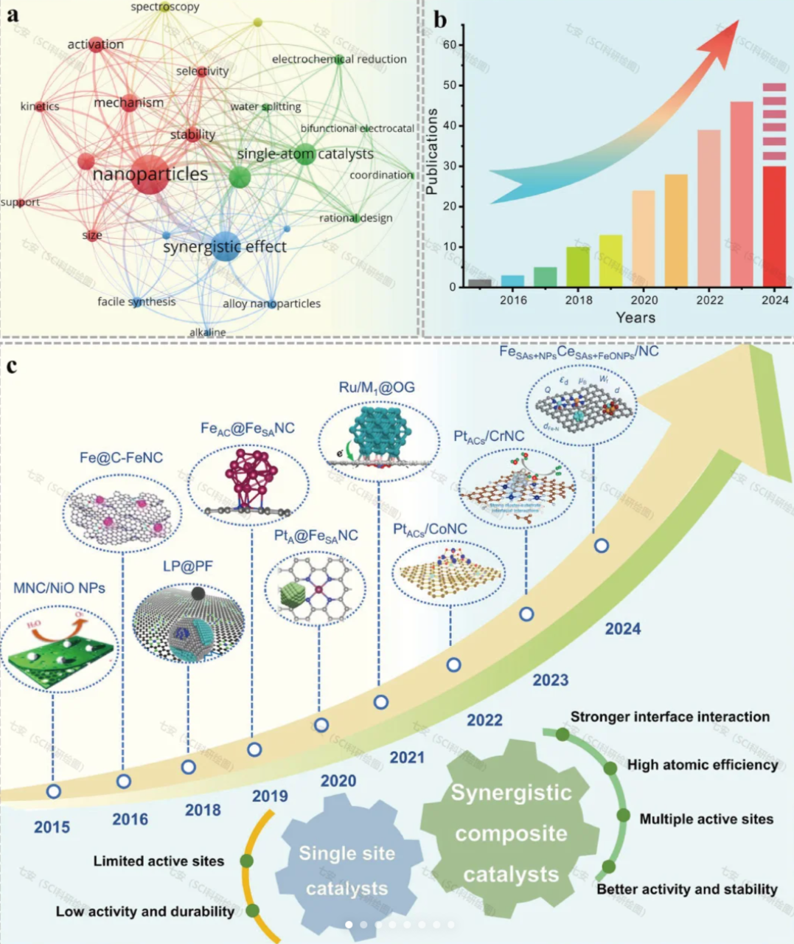
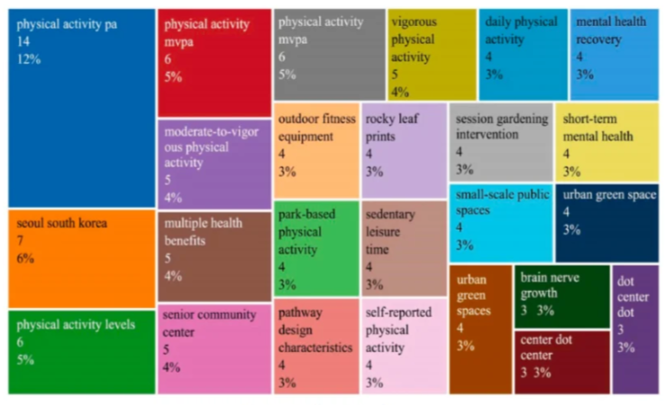

3. Overview of Keypoint Detection Techniques
- 传统计算机视觉方法（edge-based, feature-based）
- 深度学习方法（CNN, Hourglass, HRNet, Transformer, etc.）
- 三维点云或多模态方法
- 单阶段，多阶段？

4. Keypoint Detection Applications in Plant Phenotyping
应用场景占比：在五大应用场景中，作物生长活力评估占比最高（34.1%），其次是产量预测（25.6%），病虫害识别占比15.6%，反映当前研究聚焦作物健康与生产力提升。

- 典型任务：crop monitoring，叶片关键点、茎节点检测、fruit localization和计数、root结构建模，agricultural robotics，leaf morphology
- 数据集和实验设置
- 应用领域（温室、田间、果树、根系等）

5. Quantitative Comparison and Benchmarks

方法性能对比：不同算法适配不同场景，传统机器学习（如SVM）在中小样本叶绿素反演中R²达0.79；集成学习（如随机森林）在香蕉枯萎病检测中准确率达97.3%，在玉米叶绿素密度估算中R²达0.91；深度学习（如U-Net）在小麦条锈病分割中准确率达96.93%，YOLOv8在烟草植株计数中准确率达99.53%。

Keypoint detection evaluation metrics
Evaluation metrics such as precision, recall, and average precision can intuitively reflect the performance of the algorithm in the detection process. In the field of keypoint detection, the evaluation metrics for accuracy and precision include PCK(Percentage of Correct Keypoints), OKS(Object Keypoint Similarity) and AP(Average Precision) calculated by OKS. They have different focuses: PCK counts the proportion of predicted keypoints falling near the real position by setting a pixel distance threshold (e.g., a percentage of the object size or a fixed pixel value as a tolerance range), which intuitively reflects whether the localization accuracy meets the requirements of the application; OKS introduces the object scale and visibility weights, and calculates the normalized distances between predicted keypoints and the real points (taking into account the object size scaling) and assigns lower weights to the occluded keypoints. The lower weight is given to the occluded keypoints to better fit the actual detection scenarios, e.g., when part of the limb is occluded. AP (Average Precision) is the core index to measure the overall performance of the model, which is used to comprehensively evaluate the detection accuracy of the model for keypoints under different confidence thresholds. The next section will focus on these three metrics.

- PCK (Percentage of correct keypoints)
PCK represents the proportion of correct keypoint estimation. It computes the proportion of detected keypoints whose normalized distance with their corresponding ground truth (GT) is less than the threshold, which is defined as follows:
$$PCK_{i}^{k}=\frac{\sum_{p}{δ\left(\frac{d_{pi}}{d_{p}^{def}}≤T_{k}\right)}}{\sum_{p}{1}}$$
$T_{k}$ is the set threshold, $d_{pi}$ is the Euclidean distance between the predicted value and the GT of the $i^{th}$ keypoint of the $p^{th}$ object and $d^{p}$ is the normalization factor of the $p^{th}$ object. In FLIC, torso size is used as the normalized reference. In the MPII dataset, the head length is used as the normalization reference, namely PCKh. The advantages and disadvantages of the PCK metrics are illustrated next.

- OKS (Object keypoint similarity)
$$OKS=\frac{\sum_{i}{\exp\left(-\frac{d_{i}^{2}}{2s^{2}σ_{i}^{2}}\right)δ\left(v_{i}=1\right)}}{\sum_{i}{δ\left(v_{i}=1\right)}}$$
- mAP
$$\backslash [$$
$$mAP=\text{mean}AP\left(0.50:0.05:0.95\right)$$
$$\backslash ]$$

Metrics | Value Range | 解释方式 | Sensitivity / Dependency |  | Advantages | Disadvantages | Focus
PCK | % of correct keypoints within threshold α | 越高越好 | Threshold α |  |  |  | 局部位置准确性
OKS | Object Keypoint Similarity |  | Visibility weights |  |  |  | 综合考虑尺度与可见性
NME | Mean error normalized |  | Scale factor |  |  |  | 平均几何误差
mAP

分析不同任务/数据集的性能趋势
- 指出评估指标的不一致性与挑战

6. Challenges and Future Directions
技术发展趋势：无人机多光谱遥感在农业中的应用分为4个阶段，2014-2016年为技术初始应用期（聚焦无人机部署），2015-2017年为数据融合探索期，2018-2019年为系统集成期，2022-2024年进入数字农业融合期，当前研究热点向多技术协同（如AI+多光谱）和全生育期监测发展。

- 数据多样性与标注不足，标注标准不统一
- 泛化能力与可解释性
- 跨物种迁移与领域适配
- 集成大模型与自监督学习的潜力
- 环境干扰：光照变化、遮挡（如叶片重叠）。果实定位精度优于根系（因后者遮挡严重）
- 与农业知识结合：关键点如何关联生理参数（如叶倾角与光合效率）。

7. Conclusion
- 总结主要发现
- 提出研究建议与趋势展望

Data availability
All code related to the data collection and visualization is available on GitHub. Additionally, all 402 studies identified during this systematic literature review (SLR) process are accessible in this GitHub repository.

Authorship contribution statement:
Conceptualization: E.M. and S.N.; Data curation and visualization: JY.C., J.W; Writing original draft: JY.C.; Review, and editing: J.R., J.W. and S.N.; Funding acquisition: J.R. and S.N.

Declaration of competing interest
The authors declare that they have no known competing financial interests or personal relationships that could have appeared to influence the work reported in this paper.

Funding
This research was supported by two funding sources: the Science Foundation Ireland (SFI) President of Ireland Future Research Leaders Award to S.N. under Grant No. 18/FRL/6197.

Acknowledgments
Firstly, we extend our sincere thanks to the support of Agricultural Science and Technology Innovation Program (ASTIP) and National Natural Science Foundation of China. Secondly, we are grateful to the UCD Library and IT team for their provision of essential database resources. Lastly, we are also grateful to the anonymous reviewers whose comments greatly improved the manuscript.

